Electronics Catalog — Project Documentation
Sep 29, 2026 · @Suriya

Overview
Electronics Catalog is a local system that builds a catalogue of real mobiles and laptops sold in India, with a Tamil Nadu focus. For each product it records its prices, images and specifications, and which e-commerce platforms sell it. As of 29 Sep 2026 it holds 41 verified products (15 mobiles, 26 laptops) built from about 375 real retail listings.
The core rule: nothing is invented. Every product, price and image comes from a real web page or search result. It is stored with the URL it came from and the text it was read from. The local AI model is never asked to name products, guess prices or pick images.
What it produces:
- A PostgreSQL database (electronics_catalog) organised as brand → category → product → one listing per platform, with a price history.
- A web app for browsing: category → brand → product → where it is sold, at what price, and how we know.
- An admin page and a command-line tool for collecting data, grading platforms and reviewing uncertain matches.
Where it runs: only on the project laptop (Windows 11, 8 GB RAM, CPU only). The code is in C:\Electronic__Products_LLM\Electronics_Deploy. It is not in git and is not deployed anywhere.

Background: where this came from
The project is a converted copy of an earlier app, Project_Deploy, which stays untouched in C:\Electronic__Products_LLM\Project_Deploy.
The original app (Project_Deploy):
- An Indian FMCG/grocery catalogue: brands like Amul and Cadbury, with nutrition data and simulated stores.
- Built with FastAPI, React and PostgreSQL + pgvector, plus a local LLM (Ollama, qwen2.5:1.5b).
- Some of its paths invented data: a price estimator guessed prices, and one ingestion path asked the LLM to list a brand's products.
- Its settings point at a remote production database (pgvector on a hosted server). The new project never uses it.
The design document (docs/Electronics_Data_Collection_Solution_Design.docx, 28 Sep 2026) proposed scraping Amazon.in, Flipkart, Croma and Reliance Digital directly with Scrapy.
What we changed, and why:
Topic | Design document | What we built | Why
How data is found | Scrape the four big retailers | Search-first: find product pages through web search, then scrape only the platforms that allow it | Scraping Amazon and Flipkart is risky (blocks, terms of use); even Croma blocked us
Amazon.in, Flipkart | Crawl at a low rate | Never fetched; data comes from search results only | Their terms restrict automated access
Tamil Nadu | One Coimbatore pincode | TN retail chains added as platforms (Poorvika, Sangeetha, Vasanth & Co, Viveks) | Show which products TN retailers actually sell
AI model | Fill gaps from page text | Same, and every value is checked against the page text | Stop the model inventing values
Database | New database, schema elec | Same: a local Docker database on port 5433 | Keep the existing databases untouched
Codebase | New repository | Copy of Project_Deploy, grocery code removed | Reuse its API, auth, UI and AI plumbing

How it works, end to end
A collection run starts from web search, not from the retailers' sites. It reads a product page only when the platform allows it, and otherwise works from the search result alone.
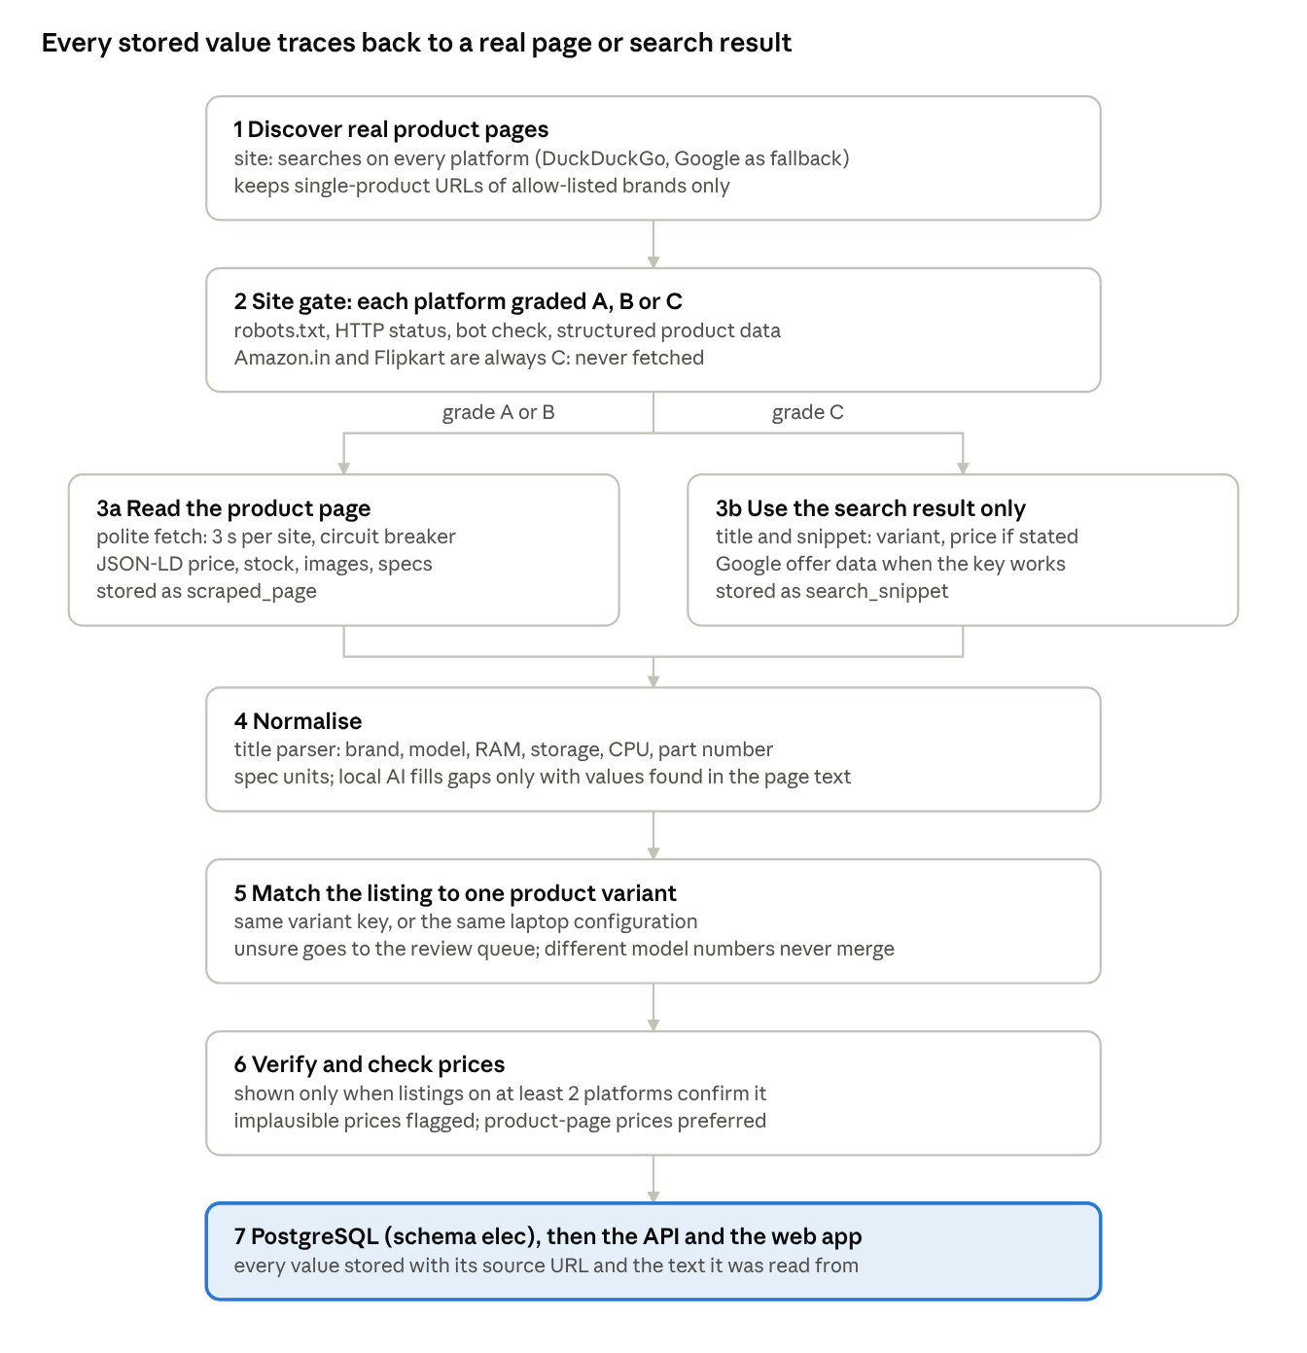
collection pipeline · 7 stages, one branch at the site gate
One run covers one category and a set of brands. After discovery, each model found is also searched for by name ("HP 15 Ryzen 5 7530U 16GB RAM 512GB price") to find the same product on other platforms. That second listing is what gets a product verified. Every request and search is logged, and search results are cached for 24 hours.

Platforms and the site gate
Every platform gets a grade that decides whether we may read its pages or must rely on web search results only. The grade comes from a probe: we find 2–3 real product pages through search and try to fetch them politely.
- A: robots.txt allows the page, it returns HTTP 200 with no bot check, and it carries structured product data (schema.org JSON-LD) with an INR price. We read the product page.
- B: the page can be fetched, but only its HTML and meta tags are readable. We read those, and take the price from search.
- C: blocked, a CAPTCHA, robots.txt disallows, or no data without JavaScript. We use search results only and never fetch the site.
Amazon.in and Flipkart are C by policy: they are never fetched, whatever a probe would say. A grade is re-checked every 7 days. Any 403, 429 or CAPTCHA response trips a circuit breaker that pauses the site for 24 hours.
Platform | Region | Grade (29 Sep 2026) | Reason
Reliance Digital | National | A | Product pages carry JSON-LD with INR prices
Vijay Sales | National | A | Same
Poorvika | Tamil Nadu | A | Same
Vasanth & Co | Tamil Nadu | A | Same
Amazon.in | National | C | Policy: never fetched
Flipkart | National | C | Policy: never fetched
Croma | National | C | Returned HTTP 403 (blocked)
Tata CLiQ | National | C | Returned a bot-check page
Sangeetha Mobiles | Tamil Nadu | C | No product data without JavaScript
Viveks | Tamil Nadu | C | Few product pages indexed by search engines
Brand websites (samsung.com/in, hp.com/in-en and others) are platforms too. Only their Indian storefront pages count, and most of them currently grade C.
Tamil Nadu prices. No platform has accepted a Tamil Nadu pincode yet, so every price is the platform's national listing price. The app says so, and marks products sold by TN retailers with a "TN retailer" badge instead of claiming TN-specific prices.

Data quality: how the catalogue stays honest
A product appears in the app only when real listings on at least two platforms, one of them a retailer, confirm it. The rules below are enforced in code and in database constraints, and covered by automated tests.
Evidence on every value
- Every listing stores its source URL and the text its values were read from: the JSON-LD fragment, the meta tag, or the search title and snippet.
- The database refuses a listing without a URL or evidence, a non-INR price, or a price outside ₹500–₹10,00,000.
- Price history is append-only: the database refuses any update to it.
- verify-grounding re-checks a sample of stored prices against their evidence. Currently 100 of 100 pass.
Reading prices safely
- Prices come only from parsers, never from the AI model.
- Search-snippet parsing rejects EMIs, "₹X off", cashback, exchange and bank-offer amounts, price ranges, and snippets that quote two different prices.
- A snippet price is dropped when the snippet names a different RAM or storage than the listing.
- Outlier check: search-result prices are cached and sometimes seller-specific. A price more than 35% away from the product-page price, or below the category floor (₹3,000 for phones, ₹15,000 for laptops), is flagged "unconfirmed". It stays stored with its evidence but is never used as the best price.
- The best price always prefers a price read from a product page over one from a search result.
Matching listings to one product
- A product is one real-world variant: phones = brand + model + RAM + storage; laptops = brand + model line + exact CPU + RAM + storage, with the manufacturer part number as a fallback.
- Titles are parsed with rules that handle each site's style ("8GB RAM, 256GB", "(256 GB) (8 GB RAM)", "8GB + 256GB"). A truncated title is completed from its own snippet only when the snippet is unambiguous.
- Models with different numbers are never merged (Galaxy S25 vs S26, A27 vs A37). Uncertain matches go to a review queue instead of being guessed.
- Colour is stored on the listing, not the product, so all colours of one variant count as one product.
The AI model (Ollama, qwen2.5:1.5b)
- Used for one job: filling missing specification fields (battery, display, camera and so on) from the page text we fetched.
- Every value it returns must appear in that same text, or it is thrown away. A test proves an invented value is discarded.
Images
- Taken only from a product's own listings: the page's structured data, or an image-search result whose source page is one of that product's listings.
- Each image is checked live (it must really return an image). Only the URL is stored; nothing is downloaded.
Unknown stays unknown
- A missing stock status is stored as unknown, not "out of stock". A throttled search counts as "no answer", not "not sold". A title too vague to identify a variant is stored, but not linked to a product.

Database
The data lives in a local PostgreSQL 16 database with pgvector, running in a Docker container. It is completely separate from the grocery project's databases.
Setting | Value
Container | elec_catalog_pg (defined in docker-compose.yml)
Host and port | 127.0.0.1:5433 (only reachable from this laptop)
Database | electronics_catalog (tests use electronics_catalog_test)
User | postgres; password = POSTGRES_PASSWORD in Electronics_Deploy\.env
Schema | elec
Storage | Docker volume electronics_deploy_elec_catalog_pgdata
- Use 127.0.0.1, not localhost. On this laptop localhost tries IPv6 first and adds about 5 seconds to every connection.
- The backend refuses to start if it's pointed at any non-local host or another database name. That guard makes it impossible to write to the production grocery database by mistake.
Tables (schema elec, created by numbered SQL files in backend/app/electronics/db/migrations/):
Table | Holds
brand, brand_alias | The 16 allow-listed brands, with spellings and sub-brands (Redmi → Xiaomi, iQOO → Vivo)
category, brand_category | Mobiles and laptops, and which brands sell each
site | Every platform, its policy, probe grade, evidence and circuit-breaker state
source_listing | One row per product page per platform: title, variant, price, stock, images, specs, URL, evidence, confidence
price_history | Append-only record of every price observation
product | One canonical variant, its merged specs and verification status
product_listing_map | Which listings belong to which product, how they matched, and review status
product_image | Validated image URLs, each tied to the listing it came from
crawl_run, fetch_log, search_cache | Audit trail of runs and every request made; cached search results
Views (what the app reads): v_brand_catalog (verified products with best price), v_product_availability (every platform's offer per product), v_best_price, and v_brand_summary.
Where the data physically is: there is no .db file. PostgreSQL keeps its data in the Docker volume above, inside Docker Desktop's virtual disk (C:\Users\srira\AppData\Local\Docker\wsl\disk\docker_data.vhdx). Never touch that file. To get a single file to copy or back up:
docker exec elec_catalog_pg pg_dump -U postgres -d electronics_catalog -F c -f /tmp/electronics.dump
docker cp elec_catalog_pg:/tmp/electronics.dump .\electronics.dump

Tools and code layout
Everything is open source and runs on the laptop. The only outside services are the search engines and the retail sites themselves.
Area | Tool | Used for
Language | Python 3.13 (virtual env backend\.venv) | Backend, pipeline, command line
API | FastAPI + Uvicorn | Read API for the app, admin API for runs and reviews
Database | PostgreSQL 16 + pgvector, in Docker; psycopg 3 | Storage, constraints, views, product embeddings
Web search | DuckDuckGo via ddgs; Google Programmable Search (optional) | Discovering product pages, snippet prices, images
Fetching | httpx + protego (robots.txt) | Polite page fetching: robots.txt obeyed, 3 s per site, honest User-Agent, circuit breaker
Parsing | BeautifulSoup + lxml | Product JSON-LD, meta tags, spec tables
Matching | rapidfuzz, custom title parser | Grouping listings into product variants
Local AI | Ollama with qwen2.5:1.5b | Filling missing specs, grounded in page text
Embeddings | sentence-transformers all-MiniLM-L6-v2 (CPU) | Vectors for product search
Command line | Typer | probe, collect, prices, rematch, report, review, verify-grounding
Front end | React 19 + Vite + Tailwind; Recharts | Catalogue and admin pages; price-history chart
Tests | pytest (194 tests) | Parsers, matching, polite client, database rules, API
Where things are (in C:\Electronic__Products_LLM\Electronics_Deploy):
docker-compose.yml local Postgres + pgvector only
start_app.bat, run_project.py one-click launcher (database + API + UI)
backend/
.env local settings and secrets (never shared)
app/main.py FastAPI app
app/api/routers/elec*.py catalogue API and admin API
app/electronics/
reference/*.yaml brand allow-list, platforms, spec dictionary
db/migrations/*.sql database schema, applied by `cli migrate`
net/ polite HTTP client, circuit breaker
search/ DuckDuckGo / Google providers, cache, query budget
probe/ A/B/C platform grading
extract/ JSON-LD, HTML meta, search-snippet prices
normalise/ brands, title parser, spec units, grounding, AI gap-fill
match/ listing → product matching, rematch
collector.py the collection pipeline
price_lookup.py Google price lookup for search-only platforms
cli.py command line
tests/ automated tests
frontend/src/ React app (catalogue, product details, admin)
To add a brand or platform, edit reference/brands.yaml or reference/sites.yaml and run seed-reference. No code change is needed.

Running it day to day
On the project laptop everything is already installed. A normal start is steps 1–3.
- Start Docker Desktop from the Start menu and wait for "Engine running". Check with docker version: both Client and Server must be listed.
- Start the database: in C:\Electronic__Products_LLM\Electronics_Deploy, run docker compose up -d. Then docker ps should show elec_catalog_pg ... (healthy) 127.0.0.1:5433->5432.
- Start the app: double-click start_app.bat. It starts the database if needed, then the API (127.0.0.1:8000), then the UI.
- Open the app at http://localhost:5173. Sign in as admin with any password; this is allowed only because the app runs locally.
- Stop: press Ctrl+C in the launcher window, then run docker compose stop. Never use docker compose down -v: the -v deletes the database.
Collecting data. Use the Admin page (choose a category and brands, then Start run) or the command line. From backend\, prefix each command with .venv\Scripts\python -m app.electronics.cli:
Command | What it does
probe | Re-grade the platforms A/B/C
collect --category laptops --brand dell --limit 8 | Discover and collect real listings for chosen brands
prices --limit 40 | Fill missing Amazon/Flipkart/Croma prices from Google's structured data (needs the Google key)
rematch --category laptops | Rebuild products from stored listings with the current rules (no web requests)
report | Counts per brand, platform and source type
review | Show uncertain matches; --approve ID or --reject ID to decide
verify-grounding | Audit: every stored price must appear in its evidence text
Useful collect options:
- --no-llm: skip the AI gap-filling. Faster, and uses much less memory.
- --no-fetch: use search results only.
- --budget N: cap the number of search queries.
- --expand N: how many models to look up on other platforms.
One run takes 10–40 minutes, depending on brands and politeness delays. Run one collection at a time.
Looking at the data directly. In HeidiSQL or pgAdmin: network type PostgreSQL (TCP/IP), host 127.0.0.1, port 5433, user postgres, the password from .env, database electronics_catalog. Open schema elec, then the views (v_brand_catalog is the best start). Read only: manual edits bypass the evidence checks.
First-time setup on a new machine:
- Install Docker Desktop, Python 3.13, Node.js and Ollama (then run ollama pull qwen2.5:1.5b).
- Copy .env.example to .env in the project root and in backend\, and set the same database password in both.
- Run docker compose up -d.
- In backend\: py -3.13 -m venv .venv, install the CPU build of PyTorch, then pip install -r requirements.txt -r requirements-dev.txt, then cli migrate and cli seed-reference.
- In frontend\: npm install.
The README.md in the project folder has the exact commands.

Status, limitations and next steps
The pipeline works end to end on live data: 41 verified products, every stored price grounded in its evidence, and 194 automated tests passing.
Category | Brands collected | Verified products | Notes
Mobiles | Samsung, Xiaomi | 15 | Other 8 phone brands not collected yet
Laptops | HP 8, Dell 5, Lenovo 4, Asus 4, Acer 4, Apple 1 | 26 | Up from 2 after laptop matching was rebuilt; MSI incomplete and Samsung not collected (the run was stopped when the laptop ran low on memory)
Known limitations
- Amazon, Flipkart and Croma prices are often missing. Free search results rarely show them. The Google key in backend\.env is loaded, but Google returns HTTP 403 ("project does not have access to Custom Search JSON API"). Once the Custom Search API is enabled for that Google Cloud project, the prices command fills them. If Google won't grant it, another source is needed.
- No Tamil Nadu pincode pricing. All prices are national listing prices. TN retailers are shown as such, but no site has accepted a pincode yet.
- Unchecked search prices. A search-result price with no product-page price and fewer than 3 prices to compare can't be sanity-checked (for example an Asus laptop at ₹1,59,990 on Flipkart). The app labels these "From web search result".
- Vague titles aren't linked. About 90 laptop listings don't state which configuration they are ("Core i5 13th Gen" with no model number), so they are stored but not linked to any product.
- Memory: on 8 GB RAM, collection with the AI model enabled can exhaust memory. Use --no-llm for large runs, and close other apps.
- Search throttling: DuckDuckGo sometimes gives no answer. Such queries count as "unknown", are cached, and are retried on later runs.
Next steps
- ☐ Enable the Custom Search API in Google Cloud (or choose an alternative), then run prices
- ☐ Collect the remaining phone brands (Apple, OnePlus, Vivo, Oppo, Realme, Motorola, Google, Nothing)
- ☐ Finish MSI and collect Samsung laptops (collect --category laptops --brand msi --brand samsung --no-llm)
- ☐ Clear the review queue on the Admin page
- ☐ Set ELEC_CONTACT in backend\.env to a real email address (it goes in the crawler's User-Agent)
- ☐ Schedule a daily price refresh with Windows Task Scheduler once coverage is complete

